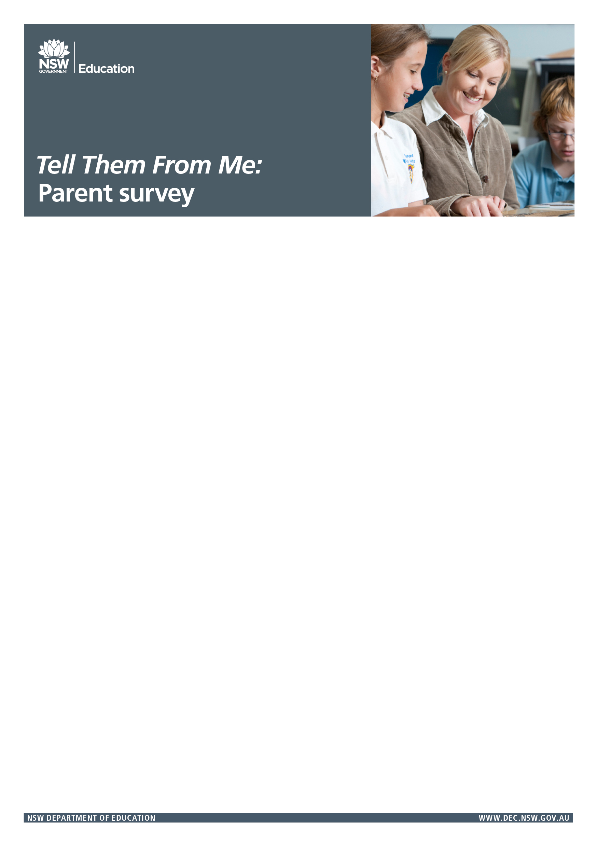

You’re invited to participate in the *Tell Them From Me (TTFM)* Partners in Learning survey, designed for parents and carers. This survey complements the TTFM student and teacher surveys, which focus on student engagement, wellbeing and effective teaching practices. All Department of Education schools have the opportunity to participate if they choose.

# Why should I participate?

Parents and carers are an important and valued part of the school community. Schools will be able to use the survey feedback to make practical improvements and inform their school plan.

# What does it involve?

This is an online survey that takes about 15 minutes to complete. It is anonymous,  
and voluntary. If you have more than one child at this school, and feel that your children’s experiences differ, you can complete the survey more than once.

# How can I participate?

You can access the survey in your own time, between 21 August and 13 October 2017.  
Follow the link below on your computer, tablet or smartphone:

**[School: Insert unique URL]**

The survey is available in English, Arabic and Chinese (Traditional). After clicking on the link above, parents will have the option to choose their language.

More information on the Partners in Learning survey can be found on the NSW Department of Education’s TTFM website:  
<http://surveys.cese.nsw.gov.au/>

You’re invited to participate in the *Tell Them From Me (TTFM)* Partners in Learning survey, designed for parents and carers. This survey complements the TTFM student and teacher surveys, which focus on student engagement, wellbeing and effective teaching practices. All Department of Education schools have the opportunity to participate if they choose.

# Why should I participate?

Parents and carers are an important and valued part of the school community. Schools will be able to use the survey feedback to make practical improvements and inform their school plan.

# What does it involve?

This is an online survey that takes about 15 minutes to complete. It is anonymous,  
and voluntary. If you have more than one child at this school, and feel that your children’s experiences differ, you can complete the survey more than once.

# How can I participate?

You can access the survey in your own time, between 21 August and 13 October 2017.  
Follow the link below on your computer, tablet or smartphone:

**[School: Insert unique URL]**

The survey is available in English, Arabic and Chinese (Traditional). After clicking on the link above, parents will have the option to choose their language.

More information on the Partners in Learning survey can be found on the NSW Department of Education’s TTFM website:  
<http://surveys.cese.nsw.gov.au/>

